Request for Coverage
FOR IMMEDIATE RELEASE – January 14, 2017
THE CATALYST COLLECTIVE NEW ORLEANS INVITES YOU TO
DownStream
Contact: Catalyst Collective New Orleans
http://www.catalystcollectiveneworleans.com
catalystcollective2016@gmail.com
201-240-2190

Where: Sanctuary Arts Cultural Center
2525 Burgundy Street, New Orleans, 70117
When: January 14th 6-9pm opening reception
What: This month's show is called DownStream, comprised of paintings, digital collages, photographs, projection pieces, poetry, and sculpture.
Who: The Catalyst Collective New Orleans:
Gason Ayisyin, Bottletree, Sean Gerard Clark, Kimberly Coleman, Miro Hoffmann, Samantha Melfi, Kelly Murray, Gamil Nassar, Charlie Steiner and Leona Strassberg Steiner.

© 2016 Charlie Steiner

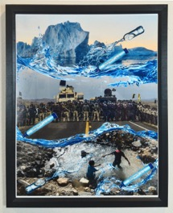
© 2017 Gamil Nassar

Catalyst Collective New Orleans is excited to announce our new gallery space, at the spacious Sanctuary Art Cultural Center in the Marigny. Catalyst Collective is an arts and social action initiative in New Orleans. The Catalyst Collective strives to support positive change in the careers of its members while also being a catalyst for positive change in the community and beyond.

For more information, interviews, photos, please contact
Leona Strassberg Steiner
CatalystCollective2016@gmail.com
http://www.catalystcollectiveneworleans.com
201-240-2190

